Project: From Farm to Fork
Difficulty: Level 2

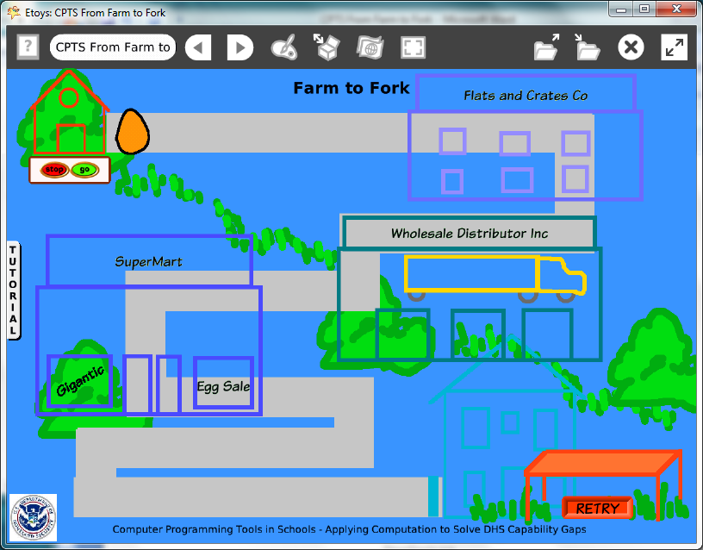

Time: Five 45 minute labs

Challenge:
Create a project maze that includes information about the food distribution network for a common food. Actual local area shops and locations can be represented or a generic model can be designed.

Programming:
This project has many objects and scripts but many of the scripts will use the same kinds of tiles. Keyboard input appeals to students who are familiar with commercially produced games. The use of keyboard input requires four scripts but the pattern of tiles is the same from one script to the next one.

Things you’ll need to know:
Quick Guides
- Paint Tools/ All
- Halo Handles/All
- Supplies: Text, All Scripts, Add a New Flap
- Script Tiles: Forward by, X and Y Tiles, Heading, Hide and Show, World Input, Random Numbers, Tests Category, Two Color Test
- Menus: Normal Ticking, Viewer Icons Set, Scriptor Icons Set, Button Fires a Script

Things to think about:
- How much factual information can be included?
- This example is a game but it could have been a book with facts illustrated with interactive objects.
- Model the jobs and machines at one point in the network.

Extensions:
- Add scripts to control the play of the game with increasing penalties for restarts.
- Add a variable for a score and a script that increases points for each destination.
- Add a time variable for time and end the game if the last destination has not been reached in a given amount of time.

NETS for Students:
http://www.iste.org/standards/nets-for-students/nets-student-standards-2007.aspx
1. Creativity and Innovation: a, b, c
2. Communication and Collaboration: a, b
3. Research and Information Fluency: a, b, c, d
4. Critical Thinking, Problem Solving, and Decision Making: a, b, c
5. Digital Citizenship: a
6. Technology Operations and Concepts: b

CSTA:
CSTA Level II: Objectives and Outline
http://csta.acm.org/Curriculum/sub/CurrFiles/L2-Objectives-and-Outlines.pdf
Level II objectives for middle school students are furthered through studying a programming language well enough that the student is proficient with it. Whether the language is Etoys, StarLogo TNG, or Scratch, it is the ability to use the language to express ideas that is valuable. A student skillful enough to use any programming language to express ideas, solve problems, model behaviors, simulate data, or to educate or entertain is an entitled person in today’s society. Topics of particular note are:
Topic 2: Problem Solving
Topic 6: Connections between Mathematics and Computer Science
Topic 11: Programming Languages
Topic 13: Multimedia

Common Core:
http://www.corestandards.org/the-standards/mathematics
6. EE.2, 6.EE.5, 6.NS.6
7. EE.3
8. F.1, 8.F.4

Teacher Notes:
Materials: Website lists for research into food distribution networks.

Comments: Objects - Scripts – Decisions
The project uses paint tools and students will need extra time to create all of their objects. One purpose of the project is to give students time to make all of the decisions about their project, both the topic and how to show the information.

This project example uses hide and show tiles for several objects and depends on X and Y locations extensively. One script uses nested conditional statements. Other scripts use location or “color sees color” conditional statements.
Example Scripts:
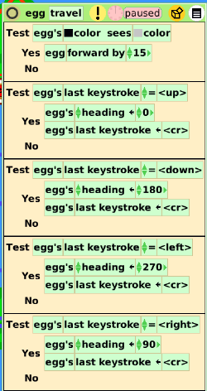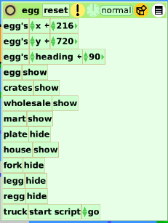

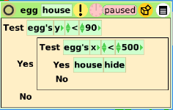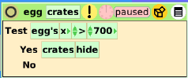

Student Notes:

Play the game:
Click go.
Use the arrow keys to change directions and move the egg from the farm to the table.
Watch out for the truck!

Think about it:
An egg weighs 2 ounces.
A carton has 12 eggs.
There are 20 cartons in a box.
There are 4 boxes in a crate.

Semi-trucks are packed with crates stacked 5 crates wide, 6 crates deep and 5 crates high.
How many eggs are in a truckload?

Each person consumes 32.5 pounds of eggs every year. How many eggs are in 32.5 pounds?

4.862 million short tons of eggs are consumed in the U.S. every year.
How many eggs are in 4.862 million short tons?
How many truck loads does it take to move that many eggs?
How much truck fuel is needed to move that many eggs an average of 50 miles per load?

What advantages and disadvantages would there be if you kept chickens in your backyard?

Egg Info:
www.foodsafety.gov
www.answers.com
www.safeeggs.com
www.roseacre.com

